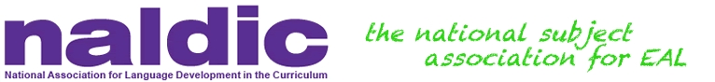

NALDIC Update April 2016

Dear Colleague

Firstly, can I thank you for your continued support. Your support is so important as collectively we can ensure that the needs of children and young people with English as an additional language are talked about, recognised and valued within our ever changing education system. As the national subject association for English as an additional language we have a responsibility to challenge unfair practice, ill-informed policies and poor guidance about English as an additional language.

Our website is still under development and we apologise for any inconvenience this has caused. We are planning on launching our new website in summer.

The NALDIC quarterly will soon be replaced by a new termly publication which will be free to members. Our new publication, EAL Journal, will be sent to members in the Autumn term. We are very excited about this new development and hope that you will be too.

We are moving offices at the beginning of May. Our new office will be based at Room B.04 Old Moray House, University of Edinburgh, Holyrood Road, Edinburgh, EH8 8AQ. For telephone enquiries, our telephone number will be 0131 651 6152. Further contact details will be available on our website very soon.

You may have seen a recent report from CentreForum, ‘Education in England: Annual Report 2016’- CentreForum. In Chapter 3 of this report, pupil characteristics, such as ethnicity, having English as an additional language (EAL) and poverty were discussed in relation to academic performance. CentreForum stated in the report that they will conduct further analysis to investigate the underlying reasons for results. We have decided to make contact with the report’s authors with a view to offering our advice and guidance in relation to any further analysis.

Kind regards

Peta Ullmann
Chair of NALDIC

